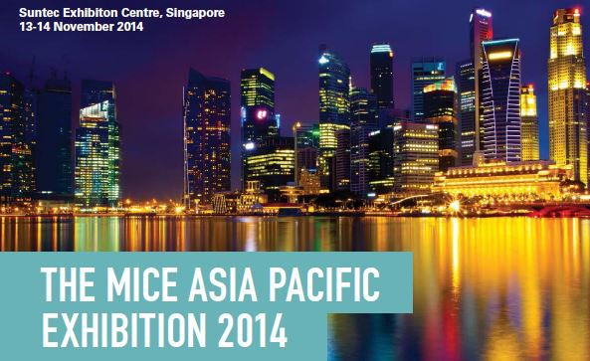
Event Tech × MICE Asia Pacific Exhibition 2014: One-Stop-Shop for Event Professionals
(Hong Kong, 19 June 2014)
Are you an events organiser worrying about event needs, schedules, planning or budgets for the coming year? Are you an event professional curious to learn about the newest trends in the MICE industry and the latest technological developments? Or are you an event technology provider looking to expand your business in Asia?
Look no further. Oliver Kinross is launching the MICE Asia Pacific Exhibition alongside Event Tech Asia 2014 in Suntec Exhibition Centre, Singapore on the 13th and 14th of November. The co-hosted events will bring together over 6,000 events professionals from across Asia Pacific, who will have the opportunity to meet one on one with over 100 of Asia's top venue, technology and supplier companies.
The MICE Asia Pacific Exhibition will be gathering event planners and organizers from all over Asia Pacific and other countries, including Malaysia, Indonesia, Singapore, Hong Kong, China, Taiwan, Thailand, India, Vietnam, Philippines, Australia, New Zealand, England, Sweden, and more. Attendee titles include company CEO, COO, Managing Director, General Manager, and other managerial and director posts. These key decision makers will be able to meet with a large variety of exhibiting suppliers and sellers to discuss their event needs and opportunities for cooperation.
The Event Tech Asia Exhibition, on the other hand, will attract participants such as event apps companies, venue sourcing and management software or solutions providers, event analytics technology suppliers. This is one of the first events to combine event technology with traditional MICE expo, offering a precious opportunity for event organisers to learn about and utilise event technology, as well as for event technology providers to connect with buyers and expand business opportunities.
Free conferences and workshops will be running concurrently with the exhibition over the 2-day expo. They will be open to visitors and exhibitors, and will feature presentations from the industry's top, most experienced speakers to cover prevalent topics in the Asian event industry.
Mr. Michael Duck of UBM Asia will be amongst the speakers to discuss the latest and emerging trends in the MICE industry in Asia. Other topics covered include guides on event planning, delegate/sponsorship sales training, online and offline marketing, recruiting and training event teams, operations and sourcing, and much more.
Apart from showcasing fresh ideas from industry leaders, as well as live demonstrations by exhibiting event and venue suppliers, the networking drinks party on the evening of day one will set the stage for establishing connections and developing opportunities for networking between buyers and sellers.
Held at the Suntec Convention & Exhibition Centre, one of the largest and most established convention centres in Asia's top convention city, Singapore, the Event Tech × MICE Asia Pacific Exhibition 2014 is guaranteed to be an enriching and enjoyable experience. With a track record of high-quality events, including the recent Africa Healthcare Summit 2014, which was shortlisted as a finalist in the Conference Awards, Oliver Kinross also promises to deliver an event that offers real value to partcipants.
The event is proving very popular, and exhibition space is selling fast. To register or for further information of the MICE Asia Pacific Exhibition 2014, November 13-14 2014, Singapore, please see below:
For exhibition space and sponsorship opportunities please contact:
Email: James.Mckenzie@oliverkinross.com
Tel: +852 3975 5710 (Hong Kong)
To register for complimentary tickets please contact:
Email: mice@oliverkinross.co.uk

